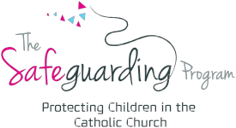

Form 15a – Cessation of Child-Related Work

Parish Name ____________________________________________________________

This form is to be completed by either the parish priest, Parish WWC Coordinator, Parish Safeguarding Officer or Director of Safeguarding and a copy forwarded immediately to the Diocesan Safeguarding Office.

First Name

Surname

Address

WWCC Number

Parish role

Our records indicate that your Working With Children card expired on _______________. Effective immediately, you can no longer continue in child-related work at the parish until notification of your new application by production of a receipt is forwarded to the Parish or Safeguarding Program Office.

A Form 3 Child Concern Referral has been received with direct implications to you. Effective immediately, and until this matter had been assessed and finalised by the Bishop and/or Professional Standards Office, you can no longer continue in child-related work at the parish.

Notification of an Interim Negative Notice / Negative Notice (please circle) from the Working with Children’s Screening Unit has been received. Effective immediately, you can no longer continue in child-related work at the parish. Upon receipt of the assessment notice from the Screening Unit, you will receive written notification from the Safeguarding Program Director as to your status to re-engage in child-related work.

This notification prevents you from making further contact with children but does not preclude you from attending Mass and participating in worship.

Signature | Date
Name | Position / Title

